Monarch Butterflies Web Hunt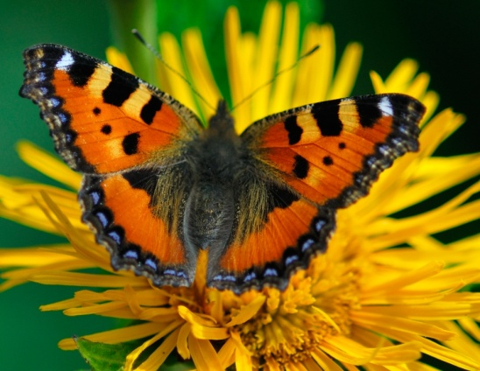

- What do monarch butterflies eat?

- What is the life cycle of a butterfly?

- Where do Monarch butterflies live?

- How can you tell if a butterfly is a Monarch Butterfly?

- What do the Monarch butterflies’ bright colors say to enemies?

- What does migrate mean?

- Why do Monarch Butterflies migrate?

- What is the life span of a Monarch Butterfly?

- How big is the Monarch Butterfly’s brain?

- What is another name for the Monarch Butterfly?

