Name________________________________________________

Healthy Heart Scavenger Hunt
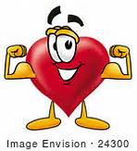

1. What does the heart pump?
2. What body system does the heart belong to?
3. Does the heart pump blood to every part of your body?
4. What influences your heart’s health?
5. What size is the human heart?
6. What is the largest artery in the heart called?
7. Name the 4 chambers of the heart.
8. Does your heart ever stop to rest?
9. What keeps blood from moving in the wrong direction?
10. Does your heart affect our emotions or feeling?

